UNIVERSITY WOMENS’ CLUB
2 Audley Square, W1K 2DB
(south end of South Audley Street)

Song Recital
Thursday, 22nd September 2011
at 7.00 p.m.
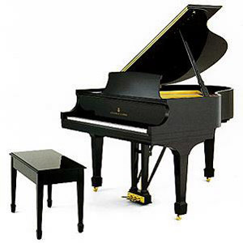
Alice Grattan – Soprano, Steven Irwin – Baritone,
Cecily Lock - Piano
Six songs by Gabriel Fauré
Benjamin Britten’s cycle ‘On This Island’ – settings of poems by WH Auden
Gerald Finzi’s cycle ‘I Said to Love’ – settings of poems by Thomas Hardy
Steven Ebal’s cycle ‘The Only World’ – settings of poems by Wendell Berry
Duets by Robert Schumann

Tickets: £15 for concert only or £30 (members) /£35 (non-members) including buffet dinner. May be reserved with lorraine@uwc-london.com or at Reception, 0207 499 2268.

